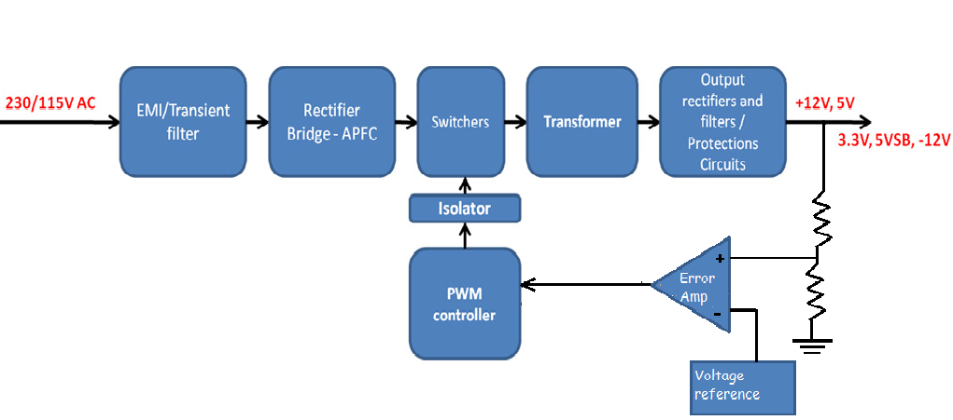

SMPS BLOCK DIAGRAM